LAB TEST-2

ASSISTED CODING

HALL TICKET NO:2403A52415

Subgroup I  
I.1 — [S20I1] Top-3 frequent words  
Context:  
Text analytics in urban public transit (metro/bus).  
Your Task:  
Top-3 words by frequency; tie-break lexicographically.  
Data & Edge Cases:  
Lowercase + split by spaces.

AI Assistance Expectation:  
Ask AI for Counter and sort keys.  
Constraints & Notes:  
Correct tie-breaking.  
Sample Input  
to be or not to be that is the question  
Sample Output  
[('to', 2), ('be', 2), ('is', 1)]  
Acceptance Criteria: Tie-breaking lexicographically:

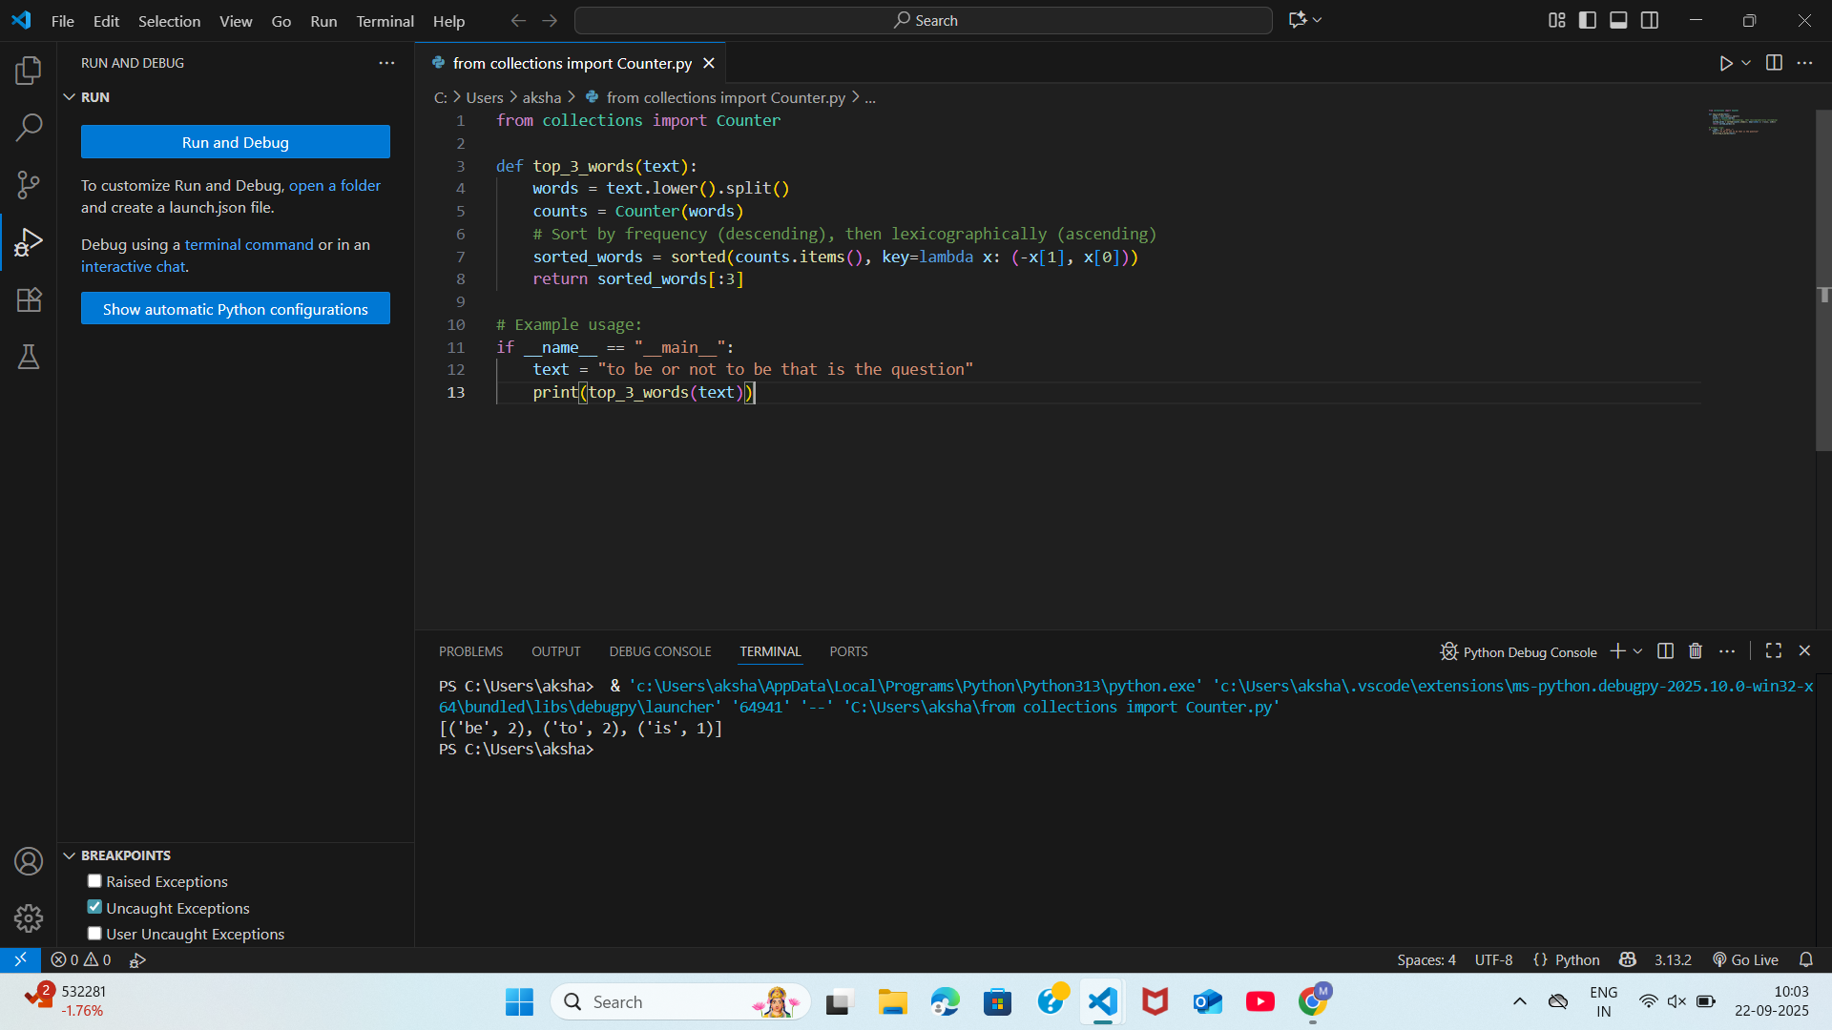

I.2 — [S20I2] Implement LRUCache (capacity 2)  
Context:  
LRU cache for urban public transit (metro/bus) service.  
Your Task:  
Implement capacity=2 LRU with get/put.  
Data & Edge Cases:  
Operations sequence provided.  
AI Assistance Expectation:  
OrderedDict approach.  
Constraints & Notes:  
Deterministic behavior.

Sample Input  
ops=[("put",1,1),("put",2,2),("get",1),("put",3,3),("get",2),("get",3)]  
Sample Output  
[None, None, 1, None, -1, 3]  
Acceptance Criteria: Correct eviction:

